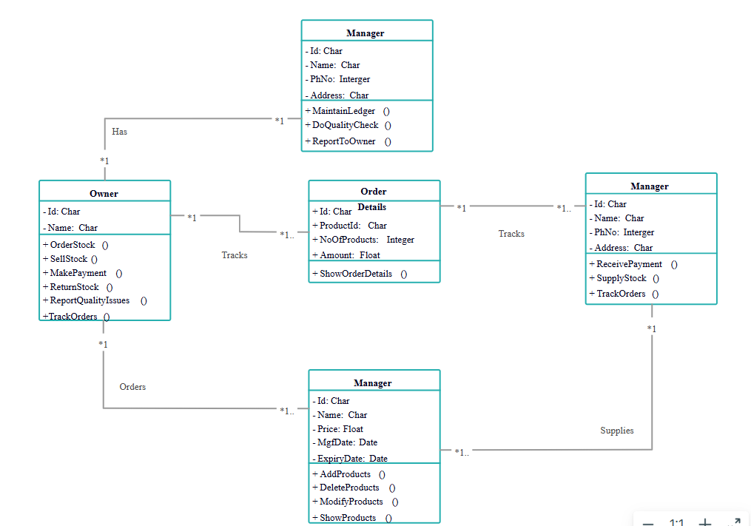

**PRACTICAL NO.06**

**Elements in a UML Class Diagram**

1. **Class**  
   Represents an entity or object in the system.  
   A class includes:
   * **Class Name**
   * **Attributes** (variables/data members)
   * **Methods** (functions/operations)

2. **Attributes**  
 Properties or data stored in the class (with visibility indicators):

* + + Public
  + - Private
  + # Protected

1. **Methods/Operations**  
   Functions that define behaviour or actions of the class.

**Types of Relationships in Class Diagrams**

**1. Association**

* A generic connection between classes.
* Represented by a straight line.
* Example: A Customer places a Sales Order.

**2. Multiplicity**

* Specifies how many instances of a class are involved in the relationship.
* Notation:
  + 1 → exactly one
  + * → many
  + 0..1 → zero or one
  + 1.. * → one or more

Example:  
 A Sales Order can have *many* SalesOrderDetail items → 1...* relationship.

**3. Aggregation**

* A "whole-part" relationship where the part can exist independently of the whole.
* Represented with a white diamond.

Example:  
 A Supplier *aggregates* Products (but the product can exist without the supplier).

**4. Composition**

* A strong "whole-part" relationship; the part **cannot exist** without the whole.
* Represented with a black diamond.

Example:  
 A Sales Order *composes* SalesOrderDetails (details have no meaning without the order).

**5. Inheritance / Generalization**

* One class (child) **inherits** from another class (parent).
* Represented with a solid line and hollow triangle pointing to the parent.

Example:  
 Sales Order and Purchase Order may inherit from a common Order class.

**6. Dependency**

* One class **uses** another.
* Represented with a dashed arrow.

Example:  
 A Report Generator class might use Product, but not own or control it.

**🔸 Quick Visual Recap**

| **Symbol** | **Meaning** |
| --- | --- |
| Solid line | Association |
| Arrow ➤ | Directional association |
| 1.. * / * | Multiplicity |
| ◇ (white diamond) | Aggregation |
| ◆ (black diamond) | Composition |
| △ (triangle) | Inheritance |
| ──➤ (dashed) | Dependency |